Assignment 1 submission-Setting Up Dev environment

* My Operating system is windows 10 pro….already installed in my pc
* I installed visual studio code as my IDE
* I have a github account already created…..as IRAN1234-I also created one repository and named it iran
* 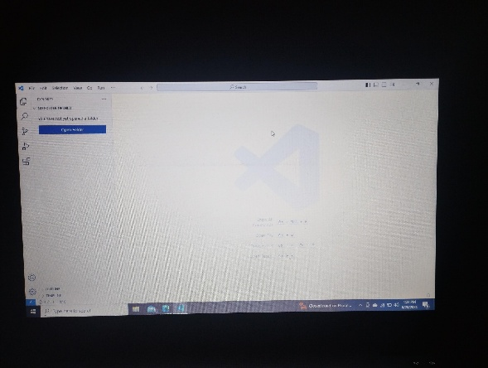Lastly I downloaded qnd installed mysql database.

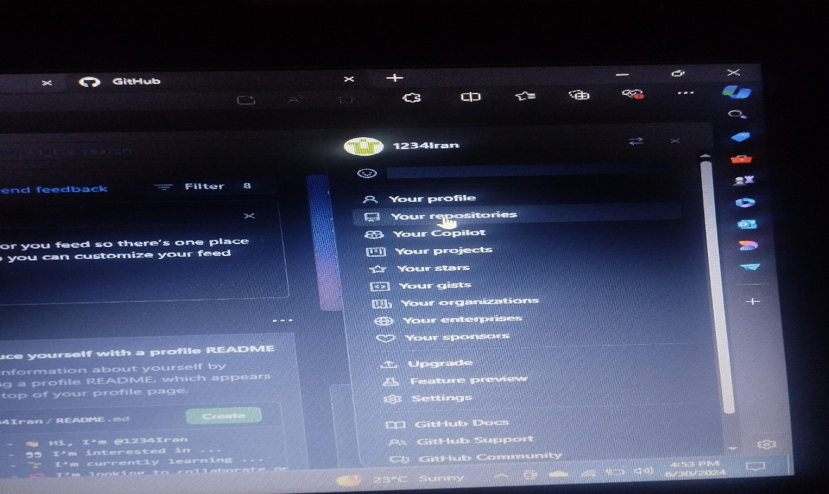All steps are accompanied by relevant photos